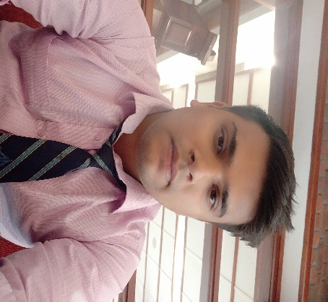***curriculum vitae***

*KARAN CHOUDHARY*

***Mobile: +91-8130860654 Permanent Address: AV-26 Staff Quarter Blind School***

***E-Mail:****Karanvardhan08@gmail.com* ***Panchkuian Road New Delhi- 110001***

### *Career Objective*

*To succeed in a environment of growth and excellence and earn a job*

*Which provide me job satisfaction and self development and help me*

*Achieve personal as well as organization goals.*

### *Educational Qualification*

* *10th passed from CBSE in 2012*
* *12th passed from CBSE in 2014*
* *Bachelor traveling studies from IGNOU...*

### *Professional Qualification*

* *Basic knowledge of ms office,excel*
* *Basic knowledge of Japanese language*
* *Diploma in international airline travel management with GDS(Amadeus) from IITC New delhi.*

### *SKILLS*

* *Positive Attitude and good communication skills.*
* *Ability to work well under pressure.*
* *Sell international packages, Hotel Booking and issue ticket from amadeus etc..*
* *Sell Flights, Airport Transfer...*
* *I have worked inbound and Outbound both...*

### *Personal Information:*

*Father Name : Sh. Rakesh kumar*

*Marital Status : Unmarried*

*Date of Birth : 07/09/1996*

*Other Activities : boxing,gym & Travelling*

*Language Known : Hindi, English & little japanese*

*Nationality : Indian*

*Declaration: I hereby declare that all the fact mention above are true to the*

*Best of my knowledge .*

*Date:*

*Place: New Delhi (KARAN CHOUDHARY)*